SC09 Jack Mackerel Working Group
Catch and sampling overviews 2021 data submission
Corresponding author: mpastoors@pelagicfish.eu
15/09/2021
Files by year
year fn
------ -----------------------------------------------------
2019 template_ALK_SPRFMO_V3 - Peru2019 - update.xls
2020 Chile 2020 2021_08_07_ALK_SPRFMO_2020_ANTIGUO.xls
2020 Peru 2020 20210915 ALK_SPRFMO_V3 update2.xls
2020 Russia 2020 20210901 ALK-SPRFMO-RUS_north.xls
2021 Chile_ALK_SPRFMO_Q1_2021_ANTIGUO.xls
2021 template_ALK_SPRFMO_V3 - Peru2021 - preliminar2.xls

page break
Overview of Jack mackerel catch and sampling overviews generated from an automated template reader. The overview is based on the ‘old’ ageing method for the Chilean data.
Catch by quarter
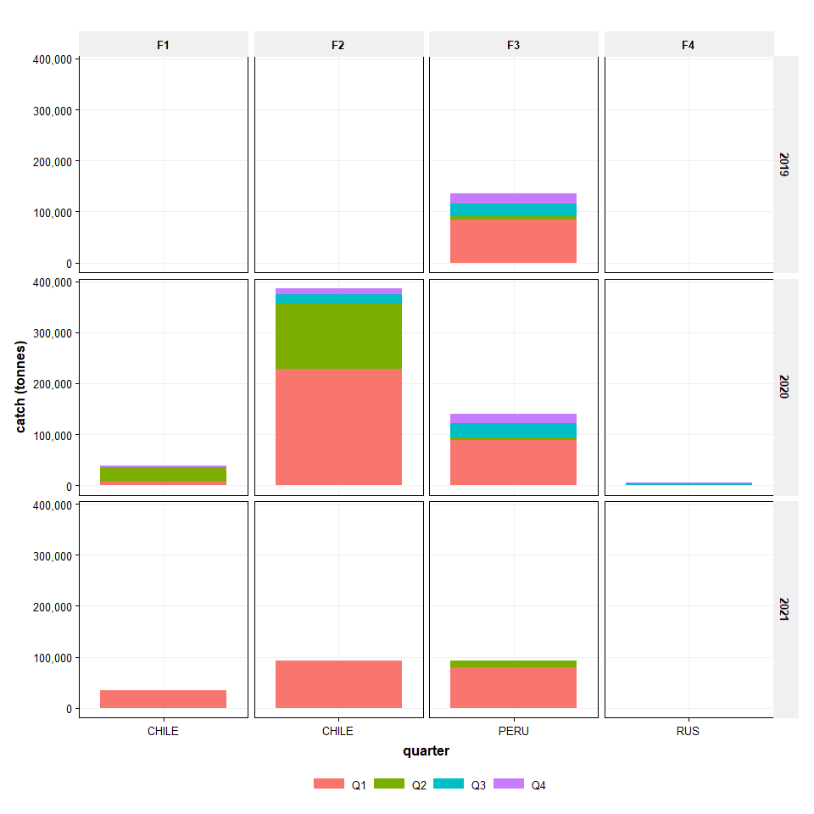

page break
Number of length measurements
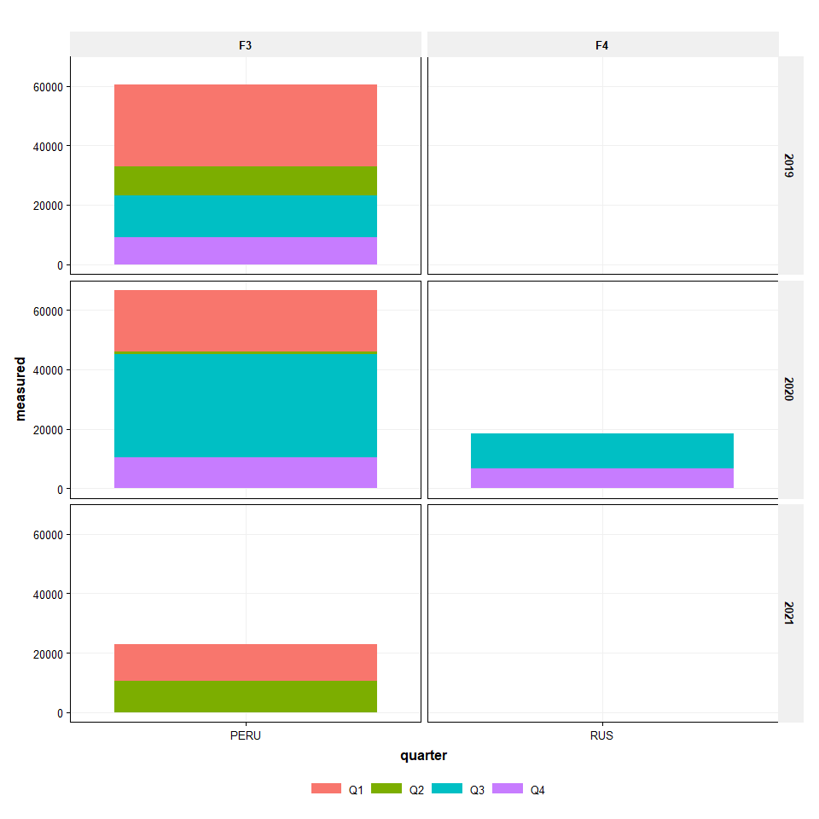

page break
Number of age measurements
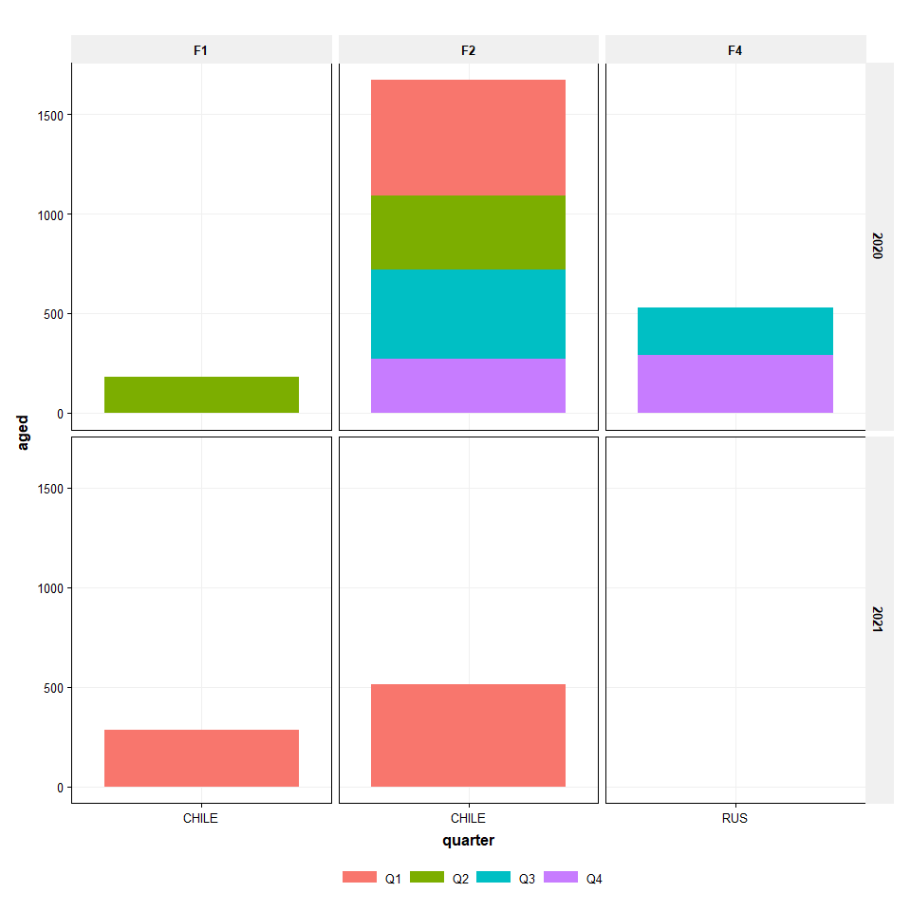

page break
Number of age measurements per ton
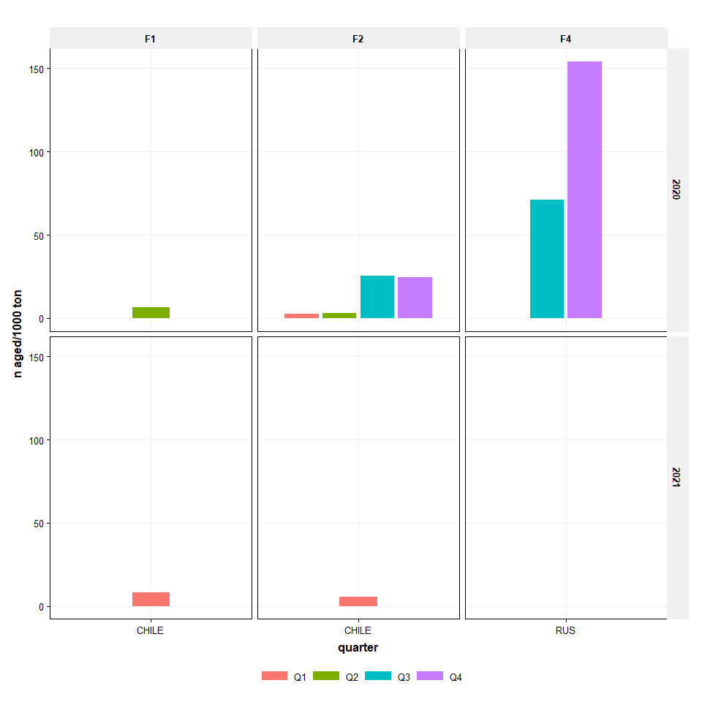

page break
Cumulative length proportions
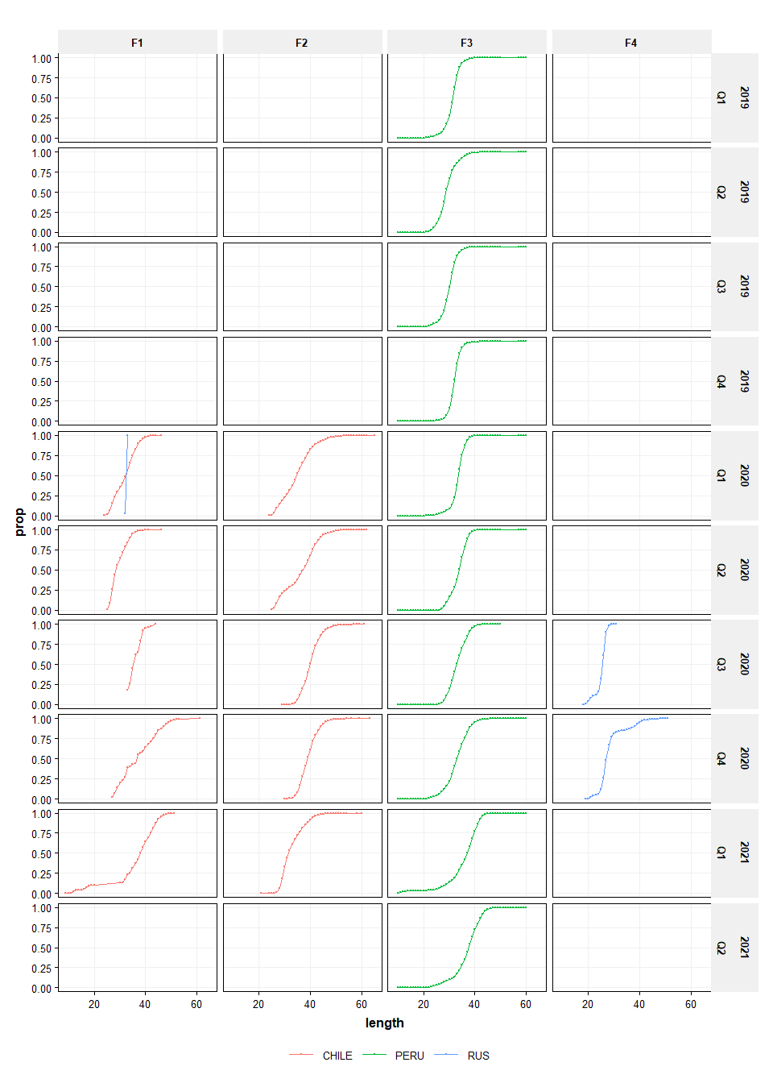

page break
ALK
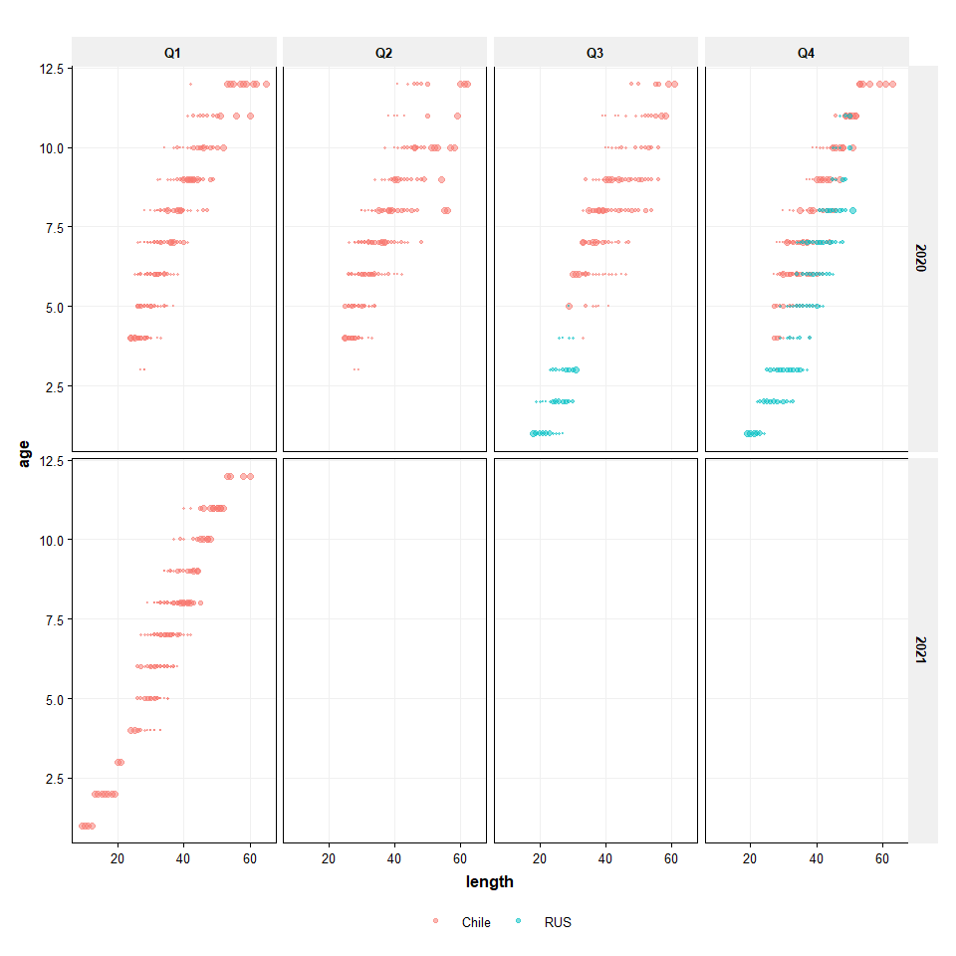
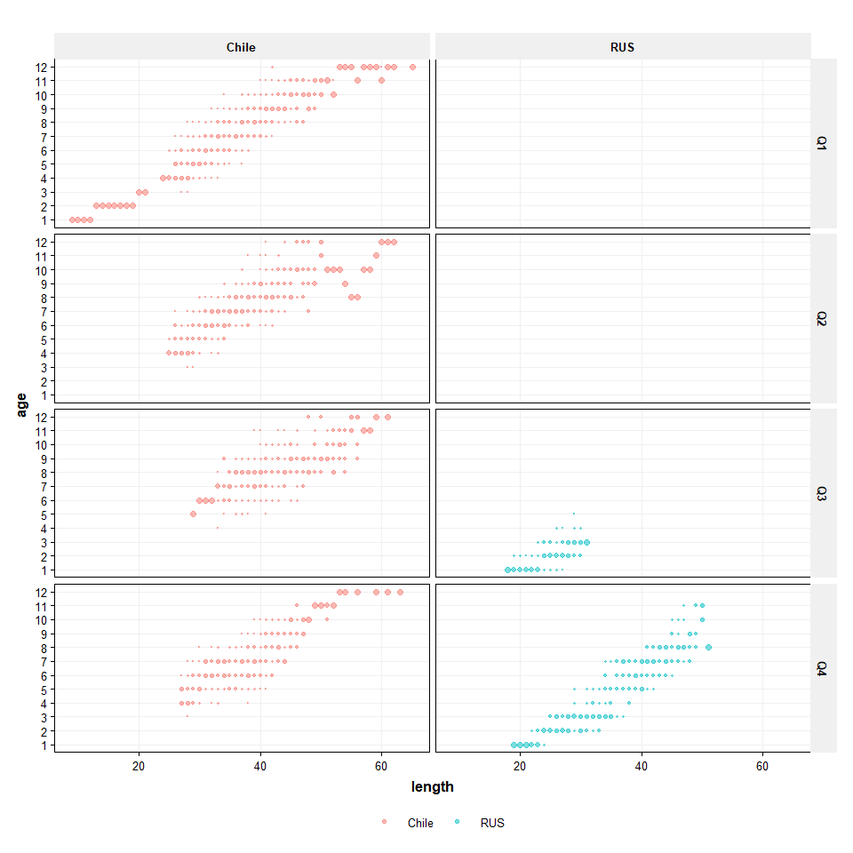
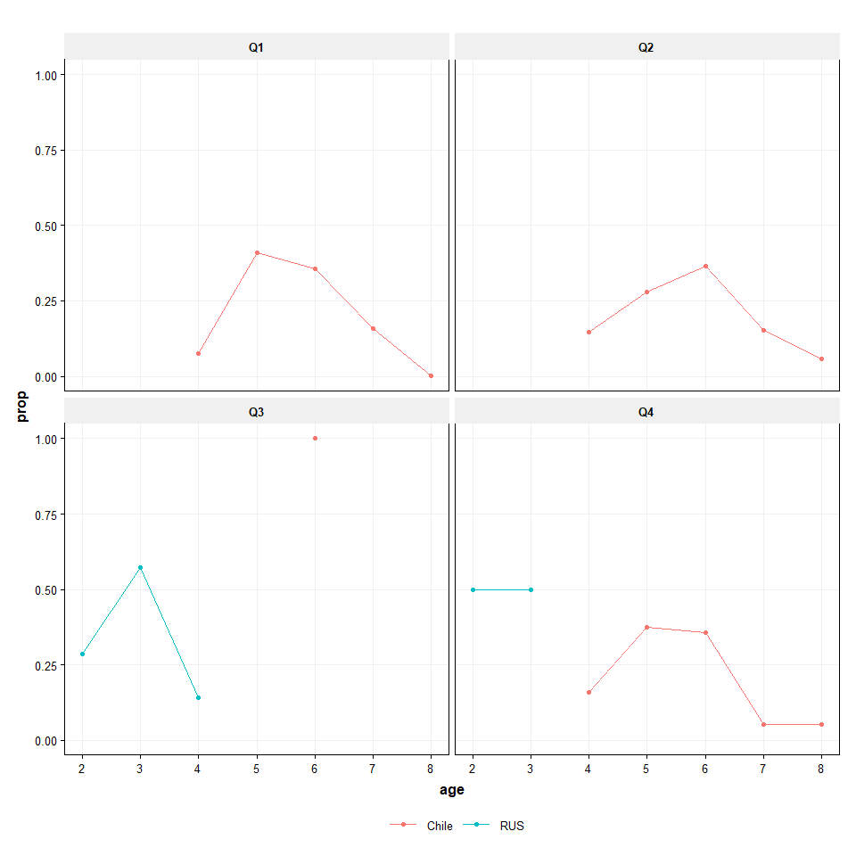

page break
CANUM
